**Debouncing**

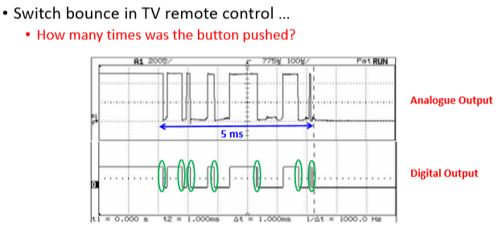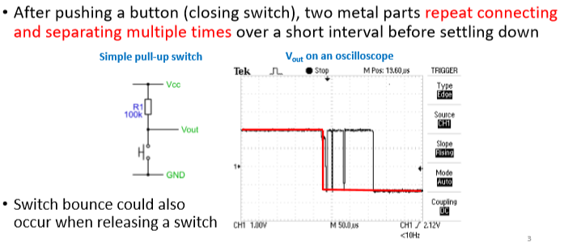**Switch bounce**

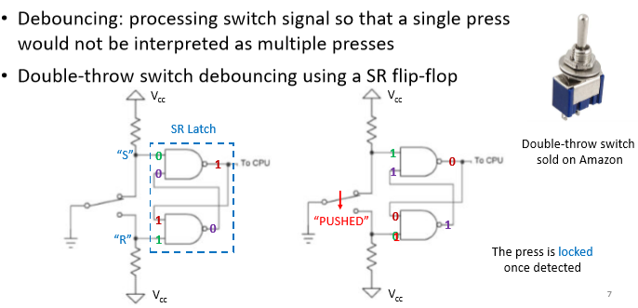

**Hardware debouncing**

* 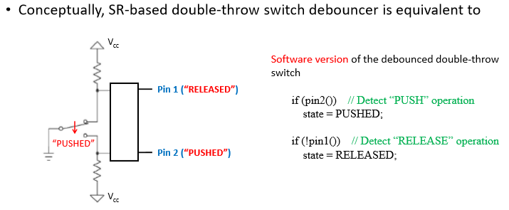double-throw switch

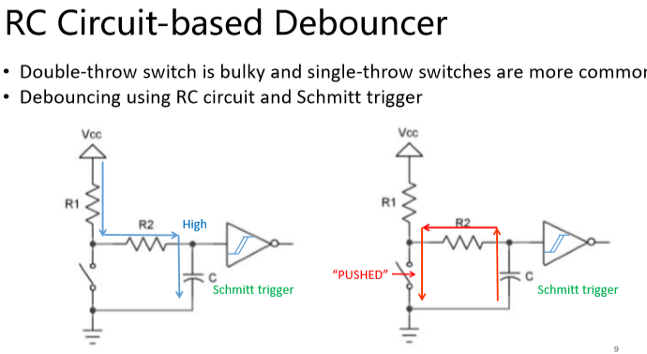

* When button is pushed = capacitor discharges

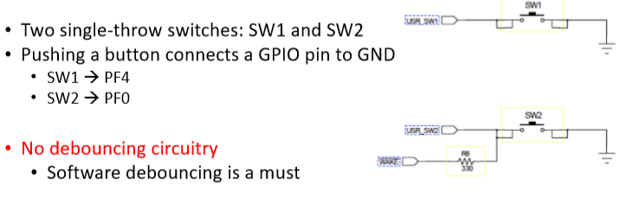

**Software debouncing**

* No debouncing circuitry on the tiva board

• Basic idea

• Switch bounce causes multiple contacting-separation cycles over a short period

• Voltage settles down after switch bounce

• N consecutive readings that are the same • Indicating that pushing/releasing a button has been completed reliably

• How to poll the pin to obtain voltage readings?

• Pin-change interrupt-based polling

• Many rapid voltage changes -> many interrupts causing MCU to be fully occupied for several ms

• Regular polling using timers (e.g., SysTick at 100 Hz)

• Still an interrupt-based approach but with better MCU scheduling

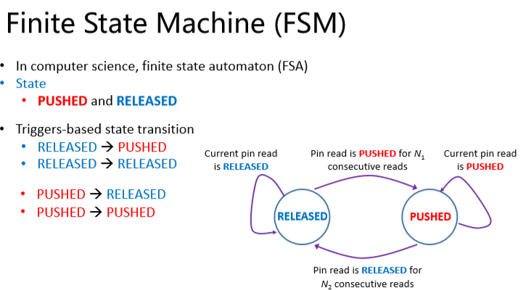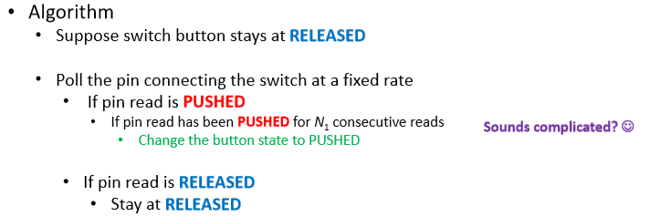

* **Four** events (purple lines)
* 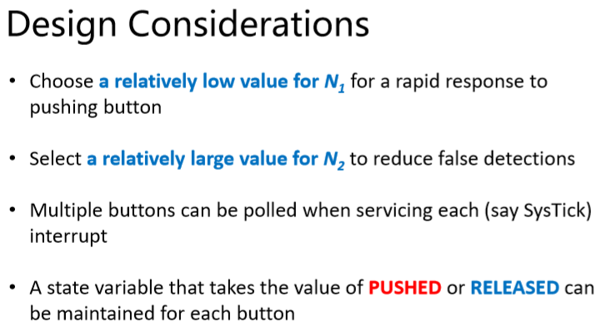**Two** Events Released and pushed
* 